**The Exeter Mentor Curriculum – Guide for Mentors**

The University of Exeter PGCE Mentor Curriculum consists of three units. The curriculum is designed to be flexible enough to cater for all Mentors whilst taking account of skills and experience. This has been co-designed with schools to minimise the burden on schools whilst having maximum impact on mentor and trainee development.

**Overview**

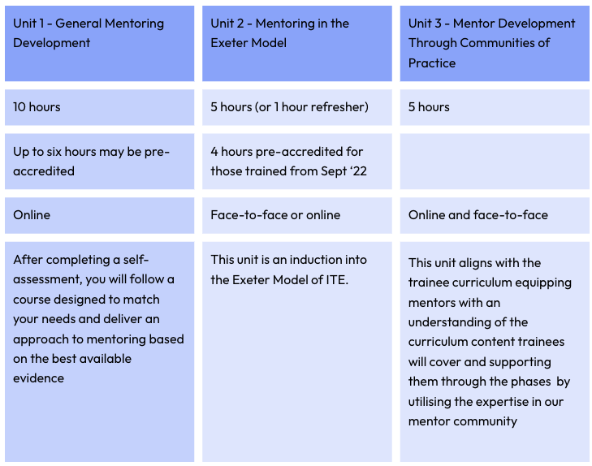

**Unit 1 – General Mentoring Development – equivalent of 10 hours**

For this we use The National Association of School-Based Teacher Trainers’ (NASBTT) Mentor Development Modules that offer a flexible suite of training resources that can be studied at a time to suit the Mentor over the academic year.

Modules are pitched at three levels to reflect mentoring experience and development need:

* Introducing
* Embedding
* Refining

There are two compulsory modules for all mentors to undertake and a wide range (currently fifty-eight) of additional modules from which Mentors select eight to create their own bespoke training package. Each module is the equivalent of 1 hour.

Our two compulsory modules are: ‘Understanding the CCF’ & ‘Mentoring Deliberately’. Mentors complete a short diagnostic assessment to help create personalised training for Mentors of varying experience and expertise. The assessment comprises of 19 questions and takes approximately five minutes to complete. The assessment recommends modules for completion based on a Mentors level of knowledge and experience, but Mentors are free to make other selections that better match their context.

* If Mentors complete NASBTT modules through a different provider it will be possible to count those modules.
* For Mentors who have completed ECF training and/or the NPQ LTD they can currently pre-accredit up to six modules - see the Unit 1 pre-accreditation matrix for acceptable pre-accreditation documents available here:

<https://www.exeter.ac.uk/students/partnership/mentoring/.>

For modules where Mentors have had alternative training input not listed on the matrix they may wish to ‘jump to the assessment’ to evidence their prior learning.

**Unit 1 pre-accreditation options for Mentors**

**Unit 2 - Mentoring through the Exeter Model – equivalent of 5 hours**

Mentors may be familiar with this unit as it is a development of the induction we have provided at the University of Exeter for a number of years. As such, we will pre-accredit four hours of this unit for those trained by the University of Exeter in the last two academic years. We will provide a list of those eligible for pre-accreditation to ITECs in June and at later dates as Mentors are matched to trainees. These mentors will then complete a one hour online ‘Mentoring through the Exeter Model Refresher’ course.

This unit is provided face-to-face and online. For Mentors attending one of our face-to-face regional offerings you will get to meet the team and the mentoring community of practice. For those completing the module online this will be asynchronous and should be completed before the trainee starts their placement.

Unit 2 covers:

Roles and Responsibilities in Mentoring in the Exeter Model  
The Exeter Model Curriculum   
Exeter Model Training Tools

Assessment in the Exeter Model

Supporting trainees

The Individual Development Portfolio

**Unit 2 Completion Options**

**Unit 3 - Mentor Development through Communities of Practice – 5 hours**

This unit will have familiar aspects to those mentors who have worked with us in previous years.

Our new Mentor Meets will replace the TD&Cs and will continue to put our expert mentors at the heart of our training. Mentor Meets occur on a termly basis throughout the year. For 24/25 these will be:

**Autumn Term 2024** – Mentors will have access to a subject based ITE curriculum video in November, from the Monday of the final placement week, of around 10-15 minutes followed by an online Mentor Meet of 30 minutes later in the week to share expertise. 0.75 hours equivalent.

**Spring Term 2025** – An online session on ‘holistic mentoring’ CPD input from experts in our mentoring community to deepen and broaden our mentoring experience and expertise. 1.5 hours equivalent.

**Summer Term 2025** – Reflections on the impact of the training undertaken and how this has improved the quality of mentoring and recommendations for the following year. 0.5 hour equivalent.

As part of this unit mentors will also receive support visits from our University Lead Mentors as part of their trainee visit to the school, regular updates, phase specific bulletins and training materials. The materials may be adapted for school 2 only Mentors and further information will be provided to them. 2 hour 15 minutes equivalent.

**Training Timeline**

***Before the trainee arrives:*** The two compulsory modules of Unit 1 should be completed or pre-accredited along with Unit 2 (either the refresher or the full 5 hours).

***Ongoing:*** The remainder of Unit 1 can be completed across the year and should be completed by 30 June 2025. Unit 3 continues across the year with inputs each term.

